**CS 3050 Quiz # 3, May 7, 2019**

**Time Limit: 75 Minutes**

**Name : Student ID:**

Note: (1) you can use a letter-sized sheet paper with notes; (2) closed-book quiz, no discussion, no use of cell phone, no calculator allowed; (3) use additional pages or reverse side of quiz pages if needed; (4) all 5 problems have equal number of points.

**1. Multiple Choices (circle the correct selection, there is only one correct answer for each problem) (4 points each)**

(1) If you apply the Breadth-first search (BFS) algorithm to traverse a graph *G,* what result will you get?



1. Linked List
2. Tree
3. Graph with back edges
4. All of the mentioned

(2) In the algorithm for computing a topological sort of a directed acyclic graph *G*, after a depth first search (DFS) on *G*, the algorithm outputs the vertices in



1. Increasing order of discovery time obtained from the DFS
2. Decreasing order of discovery time obtained from the DFS
3. Increasing order of finishing time obtained from the DFS
4. Decreasing order of finishing time obtained from the DFS

(3) Consider the directed acyclic graph *G* in the following picture:



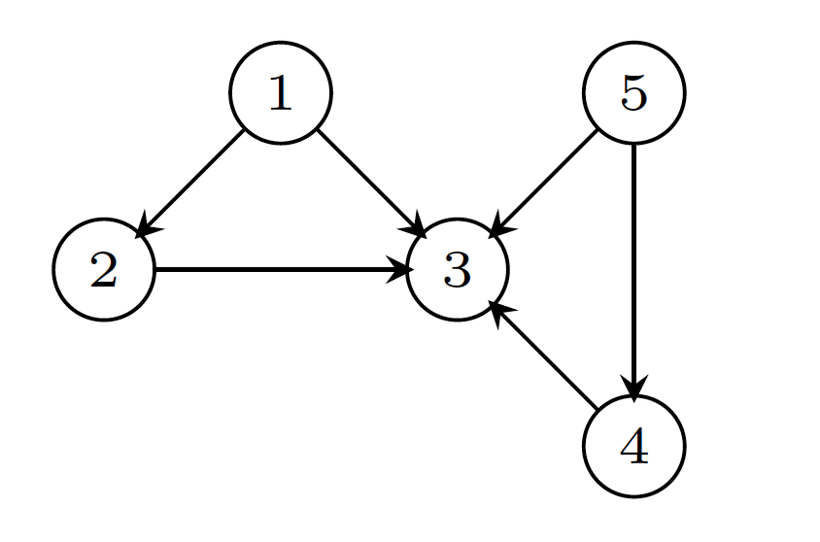

Which of the following is NOT a topological sort of *G*.

(a) 5 < 1 < 2 < 4 < 3

(b) 1 < 2 < 5 < 4 < 3

(c) 5 < 2 < 4 < 1 < 3

(d)  1 < 5 < 4 < 2 < 3



(4) Given an undirected graph *G* with *n* nodes, its *n*-by-*n* adjacency matrix has following properties: (i) all diagonal elements are 0’s and (ii) all non-diagonal elements are 1’s. Which of the following statements is TRUE?



1. Graph G has no minimum spanning tree (MST)
2. Graph G has a unique MST of cost n-1
3. Graph G has multiple distinct MSTs, each of cost n-1
4. Graph G has multiple spanning trees of different costs

(5) Given an undirected connected graph *G* with distinct edge weight, let ***emax*** be the edge with maximum weight and ***emin*** the edge with minimum weight. Which of the following statements is FALSE?



1. Every minimum spanning tree of *G* must contain ***emin***
2. If ***emax*** is in a minimum spanning tree, then its removal must disconnect *G*
3. No minimum spanning tree contains ***emax***
4. *G* has a unique minimum spanning tree

**2. Short Answers**

(1) Consider the following graph. Please list the order of nodes to be visited using **Breadth First Search** algorithm starting from node *A*? (Tie-breaking rule: If there is ever a decision between multiple neighbor nodes in the search algorithm, choose the letter alphabetically.) (5 points)

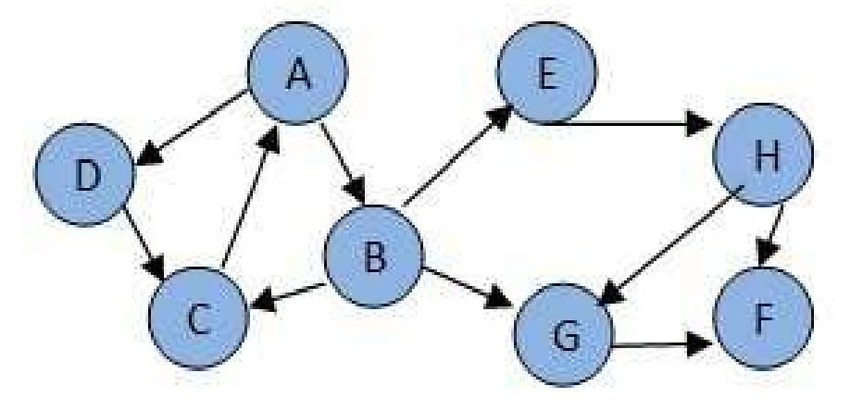



(2) Consider the same graph in (1). Please list the order of nodes to be visited using **Depth First Search** algorithm starting from node *A*? (Tie-breaking rule: If there is ever a decision between multiple neighbor nodes in the search algorithm, choose the letter alphabetically.) (5 points)



(3) Consider an undirected graph with n vertices and m edges such that all edges have same edge weights. Find an efficient algorithm to compute the minimum spanning tree of the graph? (10 points)



3. Given two words (start and end), and a dictionary, write a pseudo code to find the length of shortest transformation sequence from start to end, such that only one letter can be changed at a time and each intermediate word must exist in the dictionary. For example, given:

–start = "hit"

–end = "cog"

–dict = ["hot","dot","dog","lot","log"]

–One shortest transformation is "hit" -> "hot" -> "dot" -> "dog" -> "cog", the program should return its length. (20 points)



4. Identify all the strongly connected components in the following directed graph [You do not have to show the process] (20 points):

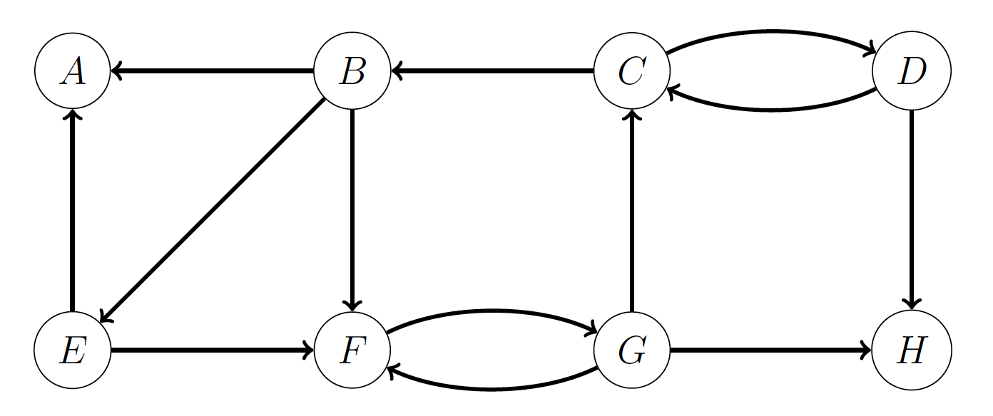

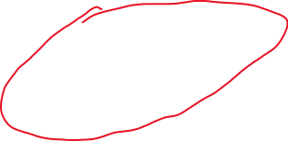

5. Given the following graph, what is the minimal cost of a spanning tree? Draw a minimum spanning tree of the graph. [You can use either Prim’s or Kruskal algorithm to solve it, and you do not have to show the process] (20 points)

